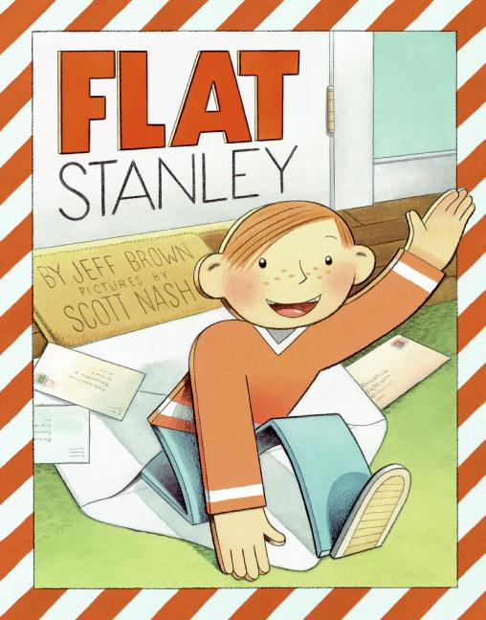
I can predict what happens in a book.
STOP – don’t open that book! First, create a mindmap of predictions about what’s inside the book. You could make predictions about characters, settings or events.

